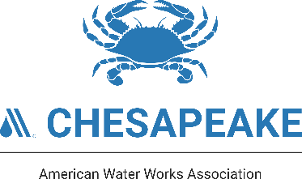
2026 CSAWWA Operator Tri-Con Scholarship Application

*Applications are due no later than midnight, Friday July 24th to edwardcopejr5@gmail.com

CSAWWA will award one scholarship to a member certified operator to attend the 2026 Tri-Association Conference (Tri-Con), which will be held September 1st - 4th, 2026, at the Roland E. Powell Convention Center in Ocean City, Maryland. The scholarship covers the cost of a Full Conference registration with ticketed events, and three nights’ lodging (Tuesday, September 1st; Wednesday, September 2nd; and Thursday, September 3rd) at one of the conference hotels. All applicants for the scholarship, or their employer, must be a member of AWWA.

Scholarship recipients are expected to attend the full conference and are required to attend the CSAWWA Business Luncheon held on Thursday, September 3rd, at 12:30 in the Convention Center. Should a scholarship winner not check in at the conference and/or attend the Business Luncheon, he/she will not be eligible for a Tri-Con scholarship again.

Only one entry per member will be accepted. You can find more information about the conference at www.ChesapeakeTricon.org. To enter, this application must be submitted by email to edwardcopejr5@gmail.com no later than midnight, Friday July 24th, 2026. The Scholarship is only valid for the 2026 Tri-Association Conference and is not transferable. If a winner is unable to attend, or receives conference funding from another source (excluding themselves), the scholarship will be awarded to an alternate winner. Additional event tickets for each winner's spouse, children or guests, as well as transportation and tolls to and from the conference, and other incidentals are the responsibility of the winner. The conference registration fee and lodging will be paid directly to the Tri-Association Conference Committee and the hotel.

Please complete and submit the official scholarship application on the following page. Substitute applications, or applications received after the deadline, will not be accepted.
2026 CSAWWA Operator Tri-Con Scholarship Application

- First Name:
- Last Name:
- Email address:
- Phone Number:
- Current Employer:
- Employer Address:
- Current Job Title:
- Membership # (yours or your employer’s)
- Does your supervisor give approval to attend the Tri-Con if you receive a scholarship? Yes or No?
- Please provide justification as to why you wish to be considered for this scholarship:

